Richmond Yacht Club Inc.  Nomination Form  AGM - Friday 27 June 2025 | 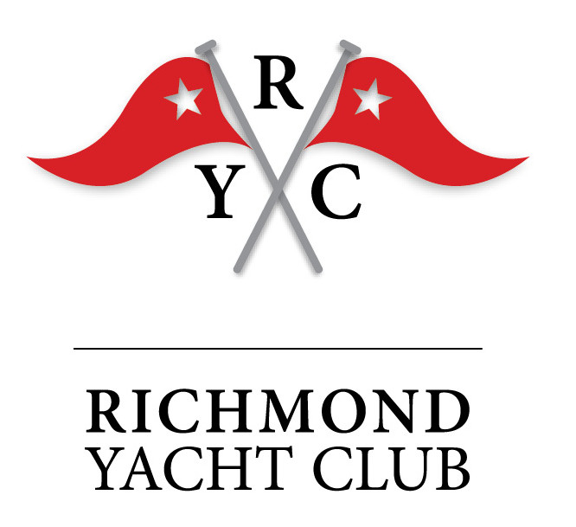

I, …………………………………,
(print name)
accept nomination to the
Richmond Yacht Club Committee.

Preferences: | ⃞ Race management | ⃞ Promotion
 | ⃞ Events | ⃞ Sponsorship
 | ⃞ Club & Building Operations | ⃞ Other ………………………..

I consent to being a member of the Committee and certify that I am not disqualified from being elected, appointed, or holding office, in accordance with the Incorporated Societies Act 2022 s 47(3).

…………………………………
(nominee signature)

Proposer: ……………………… ………………………
(print name) (sign name)

Seconder: ……………………… ………………………
(print name) (sign name)

All nominations must be on this form and lodged with the Secretary
by 2000 hrs on 20 June 2025. Scan & send to secretary@richmondyc.org.nz

Voting will take place at the AGM for the general committee as well as officers: President, Flag Officers (Commodore, Vice Commodore and Rear Commodore), Secretary and Treasurer. Officer positions are generally filled by currently-serving members of the general committee. Email commodore@richmondyc.org.nz for more information.

